Project Report
for
Stack-Overflow-Tag-Prediction
Version 1.0


Yash Gupta
BT17CSE083
Indian Institute of Information Technology, Nagpur
Department of Computer Science Engineering

Table of Contents

Table of Contents i
Revision History iii
Group Members iii
1. Final Project Summary i
1.1. Content Summary i
1.2. Lessons Learned ii
1.3. Development Strategy ii
1.3.1 Libraries iii
1.3.2 Data Cleaning - Stage 1 v
1.3.3 Analysis of Tags v
1.3.4 Data Cleaning - Stage 2 v
1.3.5 Machine Learning vi
2. Result vii
3. References viii
4. Appendix A: Vision and Scope viii
6. Appendix B: Presentation Slides 27
7. Appendix C: Other Deliverables/Artifacts 27

Revision History

Name | Date | Reason for Changes | Version
Yash Gupta | 01/02/2020 | Initial Draft (Tags Reduction) | 1.0

Group Members

Name | Role | Responsibilities
Yash Gupta | Project Manager & Developer | Oversee project activities, supervise server hardware implementations (Google Colab).

Final Project Summary
This competition tests your text skills on a large dataset from the Stack Exchange sites. The task is to predict the tags (a.k.a. keywords, topics, summaries), given only the question text and its title. The dataset contains content from disparate stack exchange sites, containing a mix of both technical and non-technical questions.

Visit - https://github.com/erYash15/StackOverflow-Tag-Prediction

Content Summary
Problem Statement

Suggest the tags based on the content that was there in the question posted on Stack overflow.

Data

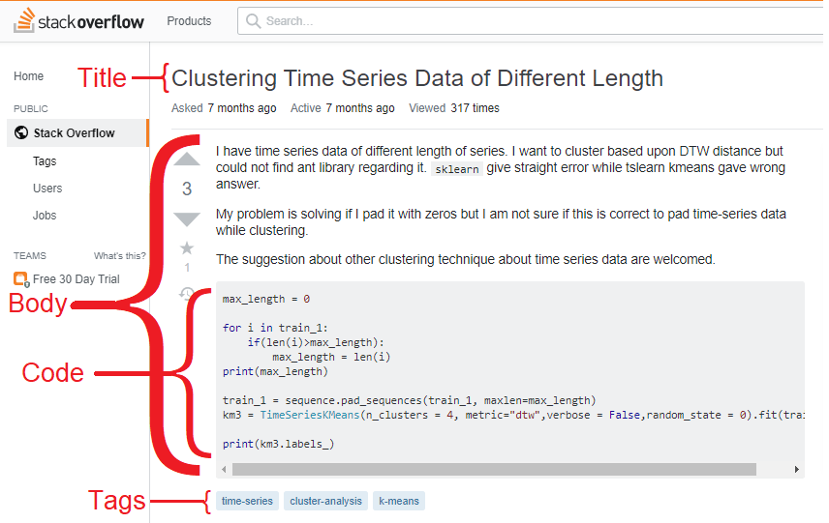

All of the data is in 2 files: Train.zip and Test.zip

Train.csv contains 4 columns: Id, Title, Body, Tags

- Id - Unique identifier for each question
- Title - The question's title
- Body - The body of the question
- Tags - The tags associated with the question (all lowercase, should not contain tabs '\t' or ampersands '&')
Test.csv contains the same columns but without the Tags, which you are to predict.

The questions are randomized and contains a mix of verbose text sites as well as sites related to math and programming. The number of questions from each site may vary, and no filtering has been performed on the questions (such as closed questions).

Source

https://www.kaggle.com/c/facebook-recruiting-iii-keyword-extraction/

Scope

This is a natural language processing and machine learning project, we will cover different types of evaluation metrics such as Accuracy, Confusion Matrix, Precision, Recall, Specificity, F1 score.

Schedule

This engagement began on January 20, 2020 and will continue through April, 2020 with the implementation of the “Exploratory Data Analysis” in first two weeks and applying different models as and when required but the project will be deployed with first model.

Costs

Hardware costs include the PC to interface with the server and cloud storage and other peripheral hardware required at both the server site as well as the reader site.

All additional costs have been development, software and programming time.

Risks

As outlined in the scope document, the risks are as follows

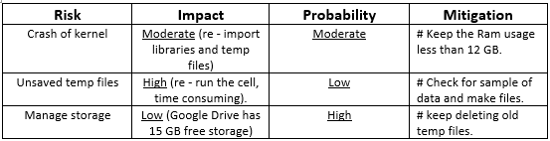

Strategy

- Libraries
- Data Cleaning – Stage 1
- Analysis of Tags
  - Tag Plots
- Data Cleaning – Stage 2
  - Training Data
  - Testing Data
- Machine Learning
  - Splitting the training Data
  - Tags Reduction

Lessons Learned
Our primary lesson learned was to dig deeper into the actual use of the final product. Question related with project:
- What is Project?
Project is taken from the Kaggle’s Facebook Recruiting III - Keyword Extraction challenge.
- Why is Project made?
Project is made for academic purpose and personal development.
- How is Project made?
Project is made on Python 3 Google Colab environment and Google Drive is used as online storage.
- For whom Project is made?
Project is made for showcase the skill acquired in field of NLP and ML.

Main Concepts used:
- Mathematics in Data Science (Statistical Techniques)
- Regular Expression
- Sparse Matrix
- Natural Language Processing (Word Tokenizer, stop words Removing, Stemming, N-gram)
- Multi-Label Classification
- Machine Learning (BOW, Logistic Regression, SVM, One Vs Rest Classifier, Grid Search)

Development Strategy
The learning outcomes were met by a variety of ways the following is a summary for each section and then following the summary is the detail for each section.

1.3.1 Libraries: Python library is a collection of functions and methods that allows you to perform many actions without writing your code.

1.3.2 Data Cleaning - Stage 1 Removing the repeat data points. Size ~ 6.5 GB.

1.3.3 Analysis of Tags Frequency dictionary of tags

1.3.3.1 Tag Plots word cloud of tags, distribution of number of times tag appeared questions

1.3.4 Data Cleaning - Stage 2 extract code, strip html, remove stop words, stemming.

1.3.4.1 Training Data Size ~ 4.5 GB.

1.3.4.2 Testing Data Size ~ 2.5 GB.

1.3.5 Machine Learning which you can then use to make predictions.

1.3.5.1 Splitting the training data 80:20 training data

1.3.5.2 Tags Reduction due to computational limitation, we reduce labels.

1.3.1 Libraries
Python 3 comes wide range of libraries.

from google.colab import drive

Mount your Google Drive on runtime using an authorization code, and write and read files.

# Basic System Libraries
import os # this helps to change working directory.
import datetime # this helps to find the running time.
import csv # write csv file
import tqdm # add progress bar

# Data Manipulation Libraries
import pandas as pd # read and write csv file
import numpy as np # used to manipulate sparse matrix

# Data Plotting Libraries
import matplotlib.pyplot as plt #premitive
import seaborn as sns #advance

# Natural Language Processing Libraries
from sklearn.feature_extraction.text import CountVectorizer
# convert all the tags convert to sparse matrix
from wordcloud import WordCloud # create word cloud
import re # regular expression
import nltk # natural language toolkit – download specify module of nltk. # Complete nltk is ~ 2.5 GB
from nltk.corpus import stopwords # has all English stop words
from nltk.tokenize import word_tokenize # convert string to words
from nltk.stem.snowball import SnowballStemmer
# stem the word to root word snowball stemmer aka porter2 stemmer

For machine learning we have used sklearn and its supporting libraries.
# Machine Learning Libraries
from sklearn.model_selection import train_test_split
# splits the datapoint in user defined ratio randomly.

1.3.2 Data Cleaning – Stage 1
Preprocessing steps:
- Remove the points with NULL values.
- Remove the repeated data points.

Results:

1. Number of Null Cells in --- Id ----are 0.
2. Number of Null Cells in --- Title ----are 0.
3. Number of Null Cells in --- Body ----are 0.
4. Number of Null Cells in --- Tags ----are 8.

Number of duplicate questions: 1827881 (30.292038906260256 %)

1.3.3 Analysis of Tags
Processing steps:
- Creating Tags frequency dictionary and saving it as csv file.
- Sort the tags frequency dictionary file in data frames in decreasing value of count.

Results:

Number of data points: 4206307
Number of unique tags: 42048

Top 10 Tags

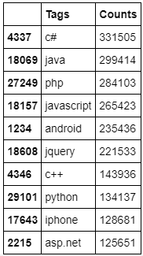

1.3.3.1 Tag Plots
Description of tags per question:

Questions with 3 tags are 1206157
Questions with 2 tags are 1111706
Questions with 4 tags are 814996
Questions with 1 tag are 568290
Questions with 5 tags are 505158

count 4.206307
mean 2.899443
std 1.211915
min 1
25% 2
50% 3
75% 4
max 5

Distribution of number of times tag appeared in all data points.
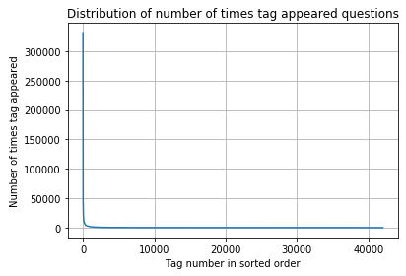
Graph shows that very few tags are highly frequent than rest of tag very less frequent. This information will be used in later section.

Word Cloud – larger size means more frequency.
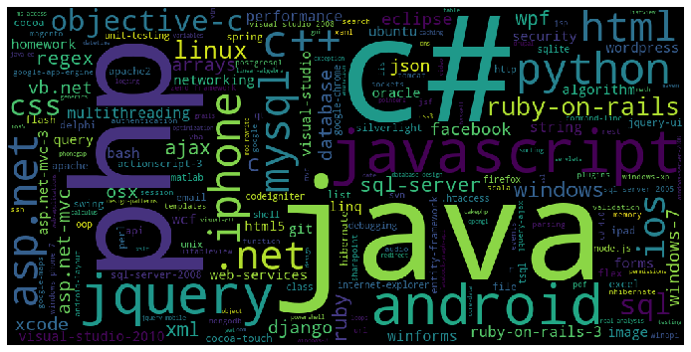

1.3.4 Data Cleaning – Stage 2
Processing Steps:
- Separate the code from Body between <code> …. </code>.
- Striping the html tags.
- Remove special characters from the Title and Body.
- Remove stop words.
- Stem al the words.
- 3 times the Title part to give more weight to it.

1.3.4.1 Training Data
All data below are with respect to Google colab free service at the time of performing the project.
Processing speed – 250-350 points per second
Processing data – 4.5 GB
Processing time – 3.5-4.5 Hours
Processed file size – 4 GB

1.3.4.2 Test Data
All data below are with respect to Google colab free service at the time of performing the project.
Processing speed – 250-350 points per second
Processing data – 2.5 GB
Processing time – 2-2.5 Hours
Processed file size – 2 GB

1.3.5 Machine Learning

1.3.5.1 Splitting the training data

1.3.5.2 Tags Reduction

1.3.5.3

1.3.5.4

Result

T

References

